2008年湖北省咸宁市初中毕业生学业考试
英语试卷
（听力录音稿和参考答案及评分说明附后）

考生注意：1.本卷共9个大题、83个小题（含3个选做题），全卷滿分120分，考试时间120分钟。
2. 本卷共8页，分听力测试和笔试两个部分。考生答听力测试和笔试选择题时，须将答案序号写在对应表格内；笔试非选择题的答案直接写在相应横线上。
3. 答题前，请先将密封线内的项目填写清楚、完整。
总分
题号 | 听力测试 | Ⅳ | Ⅴ | Ⅵ | Ⅶ | Ⅷ | Ⅸ
得分
得分 | 评卷人
第一部分 听力测试 （30分）
（共30分，1-10小题，每小题1分；11-20小题，每小题2分。）
小题号 | 1 | 2 | 3 | 4 | 5 | 6 | 7 | 8 | 9 | 10 | 11 | 12 | 13 | 14 | 15 | 16 | 17 | 18 | 19 | 20
答案序号
Ⅰ 听对话选图 听下面五则对话，根据对话内容，从每组A、B、C三个选项中，找出能回答所提问题的图片。（听完每则对话后，你都有10秒钟的时间作出选择和阅读下一小题。）每小题读两遍。
1.Which sign are they talking about?

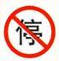
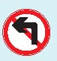

A. B. C.
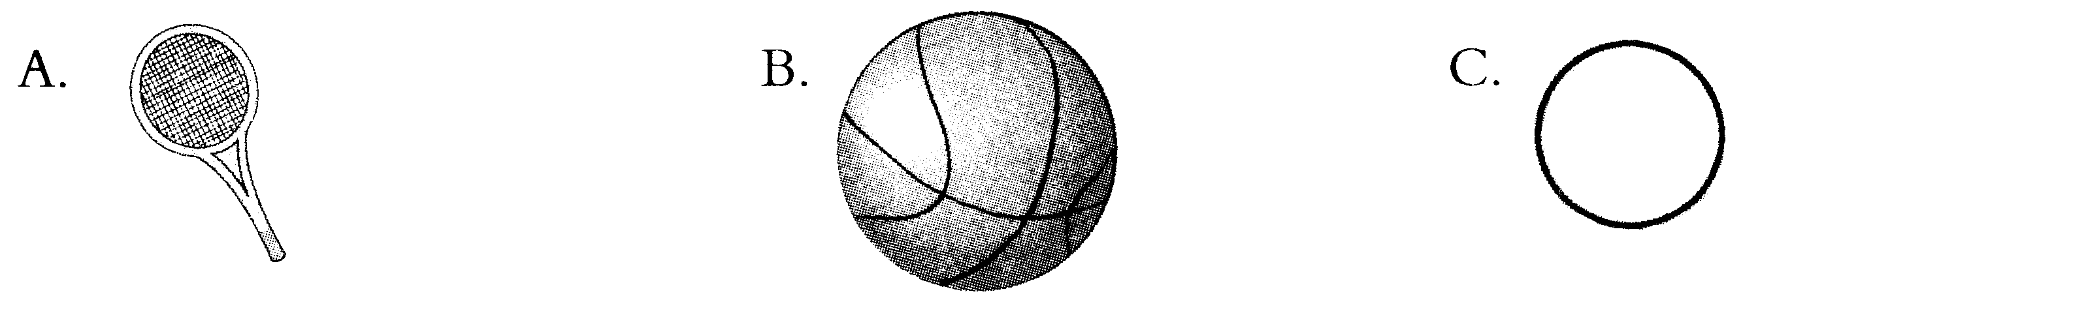
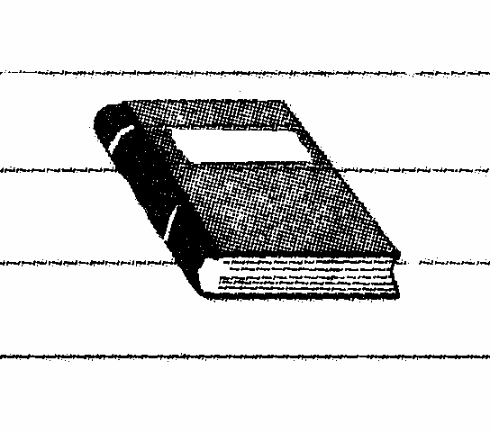
2.What will the girl probably buy for her father?

A B C

3. What does the girl want to be when she grows up?


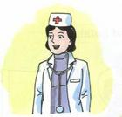

A. B. C.
4. What was the weather like last Saturday?

A. B. C.
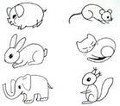
5. What animal doesn’t the man like?
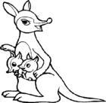


A. B. C.
Ⅱ 对话理解 听下面三则对话，回答第6—15小题。从每小题A、B、C 三个选项中，找出相应问题的最佳答案。（听每则对话前，你有20秒钟的时间作出选择和阅读各个小题。）每则对话读两遍。
听第一则对话，回答第6—8 小题。
6. What size T-shirt does the man want?
A. Size L B. Size M C. Size S
7. What color T-shirt does the man like?
A. Brown B. White C. Black
8. How much is the T-shirt?
A. $ 45 B. $ 46 C.$ 48
听第二则对话，回答第9—11小题。
9. How will Kathy spend her summer vacation?
A. Studying at home. B. Traveling abroad. C. Doing a part-time job
10. How does Kathy feel these days?
A. Bored B. Excited. C. Tired.
11. Where does the man suggest Kathy go at last?
A. Hawaii B. Switzerland C. England
听第三则对话，回答第12—15小题。
12. How far is it from their school to the zoo?
A. Only a 45-minute walk B. Only a quarter’s walk
C. Only half an hour’s walk
13. Where is the woman after she turns left?
A. On School Road B. In the zoo C. On Green Street
14. What is on the corner?
A. A coffee shop B. A hotel C. The traffic lights
15. Where can the woman get a cup of coffee?
A. In the zoo. B. On Green Street. C. In the park.
Ⅲ 短文理解 听下面一则短文，从每小题A、B、C 三个选项中，找出相应问题的最佳答案。（听短文前，你有30秒钟的时间阅读各小题。）短文读两遍。
16. Where will they go?
A. China. B. A park. C. A town.
17. How long will it take them to go there?
A. Three hours. B. More than four hours. C. Less than four hours.
18. What will they have for lunch?
A. bread and water B. apples C. both A and B
19. What’s the speaker’s mobile phone number?
A. 13726156656 B. 13926158856 C. 13726158856
20. What can they do after lunch?
A. Go shopping. B. Go camping. C. Go boating.
得分 | 评卷人
第二部分 笔试部分 （90分）
Ⅳ 单项选择 从A、B、C、D 四个选项中，找出可以填入相应空白处的最佳答案。（共15分，每小题1分）
小题号 | 21 | 22 | 23 | 24 | 25 | 26 | 27 | 28 | 29 | 30 | 31 | 32 | 33 | 34 | 35
答案序号
21. --- Morning, class! Good luck to all of you in the exam!
--- Morning, teacher. ________.
A. The same to you. B. You, too.
C. Thank you. D. I’m sorry I can’t.
22. --- I don’t think teenagers should drive cars.
--- _______. They aren’t serious enough.
A. I agree B. I don’t agree C. I think D. I don’t think
23. ---If there are ______ people driving , there will be ______ air pollution.
--- Yes, the air will be fresher.
A. less; less B. less; fewer C. fewer; fewer D. fewer; less
24. ---There are many volunteers ______ are helping the children in Sichuan.
--- And most of them are college students.
A. which B. when C. whose D. who
25. --- You always spend only a little time on your study. You really _____ me down.
--- I’m sorry, Mum. I won’t do that again.
A. take B. put C. let D. look
26. --- Can you_____ your little brother? I’m busy now.
--- OK. I’ll do it right now.
A. wear B. put on C. dress D. in
27. --- All the clerks went home _____ Mr. Wang. Why?
--- Because he had to finish his work.
A. except B. besides C. without D. beside
28.--- Some of the plastic bags can’t ______ after June1.
--- Yes, people will use environmental bags instead.
A. use B. be use C. be used D. are used
29. ---_____you _____ out the problem, Sam?
--- Not yet, but I’m going to.
A. Did, work B. Are, working C. Have, worked D. Will , work
30. --- Could you tell me _____ ?
--- Because she likes her students very much.
A. why so many students like the teacher
B. why do so many students like the teacher
C. why did so many students like the teacher
D. why so many students liked the teacher
31. ---Would you mind ______ your bike?
--- No, not at all. I’ll put it under the tree right away.
A. move B. to move C. moves D. moving
32. --- _____ did you tell him about the news?
---By ____ an e-mail.
A. How; sending B. How; send
C. How; sent D. What; sending
33. ---______ do you go hiking?
--- Once a week.
A. How many times B. How often C. How long D. How soon
34. ---What are the people in Korea supposed to do when they meet for the first time?
--- They are supposed to _______.
A. kiss B. bow C. say hello D. shake hands
35. --- The sports shoes must be Linda’s.
--- No, they _____ be. They’re too small for her.
A. mustn’t B. can’t C. may not D. might not
得分 | 评卷人
Ⅴ 完形填空 阅读下则短文，掌握其大意，从每小题所给的四个选项中，找出可以填入相应空白处的最佳答案。（共15分，每小题1分）
I can’t remember when I started collecting litter. But it was when I got tired of (36)_____litter nearby and realized that(37)_____ was going to pick it up.
小题号 | 36 | 37 | 38 | 39 | 40 | 41 | 42 | 43 | 44 | 45 | 46 | 47 | 48 | 49 | 50
答案序号
I live near a (38)_____ in Enshi, Hubei Province. I can walk there in three (39)_____! I (40)______ love going there to play with my dog. But one day there was so much litter there that I became very unhappy. I decided I had to clean up the forest. I wanted to (41)______ happy going there again.
I made my (42)_____ trip to clean the forest that afternoon. I took a big black rubbish bag with me. Ten minutes (43)_____ starting to pick up litter, my bag was full! It had cans, bottles, broken glass and newspapers in it. From then on, I went to the forest four times a year to pick up the litter. I often (44) ______ there for three hours. It makes me feel (45)_____ to do something for the environment.
After each trip , I(46) _____all the litter that I’ve found. If (47)______ of it is recyclable(可回收的), I keep it. I can’t (48)_____ why people drop litter. But I will keep picking it (49)_____ they stop dropping it. I know I am only doing a small bit to help(50) ______, but I still think it is important.
36. A. see B. seeing C. look D. looking
37. A. no one else B. I C. everyone D. anyone
38. A. school B. forest C. river D. park
39. A. months B. hours C. days D. minutes
40. A. would B. do C. am used to D. used to
41. A. look B. feel C. make D. see
42. A. first B. third C. fourth D. fifth
43. A. after B. later C. before D. of
44. A. play B. go C. work D. sit
45. A. worried B. sad C. disappointed D. great
46. A. bury B. burn C. sell D. look at
47. A. many B. little C. any D. much
48. A. wonder B. ask C. hope D. understand
49. A. until B. as C. after D. when
50. A. myself B. the earth C. other D. the litter
Ⅵ 阅读理解 阅读下面三则短文，掌握其大意。51—60 ，从每小题所给的四个选项中，找出最佳答案；61—64小题，在相应横线上按要求答题。（共28分, 每小题2分）
得分 | 评卷人
小题号 | 51 | 52 | 53 | 54 | 55 | 56 | 57 | 58 | 59 | 60
答案序号
Passage A
Are you carrying too much on your back at school? You’re not alone. Back experts(专家) in the USA are worried about that young students are having back and neck problems because they are carrying too much in their backpacks .
“It hurts my back when I run,” said Ebelin Reyes, a student in Virginia. “It’s hard to get up the stairs with my backpack because it’s too heavy.” Students have to carry heavy backpacks on their backs for a whole week’s study. Ebelin is one of them. They have regular(固定的)backpacks with two straps(带子) to carry them, but a number of students with heavy loads(负担) have switched to rolling backpacks. The backpacks have wheels and can roll on the ground. Shirley Park’s backpack weighs 10 kilos, and she said, “I’ll change to a rolling backpack because I am starting to have back pain.”
How much is too much? Experts say that students should carry no more than 10% to 15% of their own body weight. A few students have had a good idea to lighten(减轻) the load: less homework.
Doctor’s suggestions:
⑴ Lighten the load. Take home only the books the students need that day.
(2) Wide straps are better. They can send out weight over your shoulders (肩)and be sure to wear backpacks with two straps.
(3) The heaviest things should be packed closest to the back.
(4) Bend(弯曲) both knees when you pick up the pack, don’t just bend over the waist(腰).

51. The main idea of the passage is about _______.
A. the problems made by rolling backpacks
B. the advantage of backpacks
C. the best backpacks for students
D. how to lighten students’ backpacks
52. From what Ebelin Reyes and Shirley Park said, we know______.
A. students like to carry heavy backpacks
B. students have to do a lot of homework
C. backpacks with wheels are bad for students
D. students have no time to play because of heavy backpacks
53. The underlined word “switch to” means______.
A. use for B. turn to C. catch up D. begin to use
54. According to the experts, it’s better for a student of 40 kilos to carry a backpack of ____ at most.
A. 10 kilos B. 8 kilos C. 6 kilos D. 7 kilos
55. If students follow the doctor’s suggestions, they______.
A. may do less homework
B. may feel their backpacks are lighter
C. can learn how to enjoy themselves
D. will know why to wear heavy backpacks
Passage B
To the students of Class3
◆Examinations start on June22nd and end on June23.
◆For the PE test, go to the gym. For the music test, go to the Piano Room. All else are written tests. They will be held in classroom3.
English June22 8:30 A.M. – 10:00 A.M.
Math June22 10:30 A.M.—12:00 A.M.
History June22 2:30P.M.—3:30 P.M.
PE June23 8:00A.M.—10:00A.M.
Music June23 1:00P.M.—3:00P.M.
◆If you have questions, go to the Teachers’ Office before the test.

Hand-foot-mouth disease (HFMD), characterized by fever, sores in the mouth and rashes(疹) on hands and feet, is not a new infection（传染） and is common among（在……之间）infants（幼儿）and children. It is caused by up to 20 types of virus（病毒）but has similar symptoms(症状). But it usually does not lead to death. Many kindergartens(幼儿园) have to be shut because of it.

When you have completed a writing task, allow 5-10 minutes to read it and check for mistakes. In particular, look for:
◆incorrect agreement（不正确的搭配）of subject and verb: My friend likes… NOT My friend like…
◆ incorrect use of tenses（时态）
◆ wrong expressions

The 2008 Olympic torch which was named “lucky cloud” was lighted on Monday in Ancient Olympia, marking the start of the domestic(国内的) and international torch relay（火炬传递） that will end on August8 with the Games’ opening ceremony（仪式）.
The Beijing Games relay is the longest ever planned, lasting 130 days and covering 137,000 kilometers worldwide, traveling to 20 countries.

56. When were the written tests held?
A. Only on the morning of June22.
B. Only on the morning of June23.
C. On the morning and afternoon of June22.
D. On the morning and afternoon of June23.
57. Tom still has some questions about the exams, he can_____.
A. ask his teacher at any time
B. find his teacher on the playground
C. ask his teacher on June 22 or June23
D. go to the teachers’ office on June21 and ask about them
58. Which of the following is true according to the second news ?
A. If a middle school student Tom has a fever, he must get HFMD.
B. HFMD is only caused by a new type of virus.
C. Everyone will die if he gets HFMD.
D. All the children should keep their hands and feet clean to stop HFMD.
59. The third news mainly tells us _______.
A. the incorrect agreement of subject and verb
B. the incorrect use of tense
C. the wrong expressions
D. we should check our writing tasks after we have finished them
60. Which of the following is NOT mentioned in the last news?
A. Who will be the first Chinese torchbearer (火炬手)
B. When the torch relay will end
C. How many countries the torch will travel to
D. The name of the torch
Passage C
CCTV held a charity show in May to raise money for the earthquake-hit areas in Sichuan. Many famous stars took part in the show. (A) They didn’t ask for any pay, they all did it for free. There were a lot of performances like singing, dancing and cross-talks(相声 ). (B)The audience(观众) were so excited that they clapped(鼓掌) their hands all the time. Almost everyone was moved to cry by a lot of sad or moving stories. During the performances, they donated money to the disaster areas(灾区). The show was so successful.
Besides that, many other stars are doing things for disaster areas in many ways. Kungfu star Jackie Chan and the foundation(基金) named Hong Kong Emperor Group have together donated 10 million yuan. And he also sent his consolation(安慰) to the people in the disaster areas and encouraged them to hold on because “People all over the country are with you.” Xiao Ke, a songwriter, wrote and recorded a song “I Know You Will Come” to warm the hearts of the people in despair(绝望). CCTV’s top show “The Same Song” also held a charity special to help them.
Both the ticket money and the donated money will be sent to the disaster areas. As the Chinese saying goes (C) “One in trouble, all to help.” I believe that the whole world will become better if everyone of us gives charity to others.
61. 用without把（A）句的两个单句连成一个句子。
They did it __________ any __________.
62.把（B）句改写成意思相同的简单句。
The audience were _____ ______ to clap their hands all the time.
63. 将（C）句翻译成汉语。
____________________________________________________
64. 用斜体句中的“both…and” 仿造一个句子。
_______________________________________________________
得分 | 评卷人
Ⅶ 短文填空 阅读下则短文，然后在空白处写出适当的单词，单词的首字母已给出。（注意：共有12个空供你选做，每做对1个得1分，滿分10分！有的词要注意词形的变化哟！）
Swimming is very popular in summer. People like swimming in summer because water (65)m______ people feel cool. If you like swimming and swim in a wrong place, it may not be safe(安全的). Last summer, more than ten people died (66)w______ they were (67)e_______ themselves in the water, and (68)m______ of them were students. But some people are (69)s_____ not careful in swimming. They often think they swim so well that(70) n_____ can happen to them in water. Summer is here again , if you go swimming in summer, don’t forget that better swimmers have died in (71)w______. They (72)d______ only because they were not (73) c______, not because they could not swim. So don’t get into water when you go swimming (74)y______, go with your teachers or your parents. If there are “No (75)S______” sign, don’t get into water, either. If you (76) r______ these, swimming will be safer.
65. m_______ 66.w_______ 67. e________ 68.m_________
69. s_______ 70.n________ 71.w_________ 72. d________
73. c_______ 74. y________ 75. S________ 76.r_________
得分 | 评卷人
Ⅷ 补全对话 阅读下面这则对话，在空白处填入适当的句子，使补全后的对话意思完整，结构合理，上下连贯。每个空白处只能填写一个句子。（有的小题可能有多个答案，你能写出最满意的那句吗？）（共10分,每小题2分）
(Chen Ming = C; Li Hua = L)
C: Hello, Li Hua . Why didn’t you come to the party last night?
L: Oh, my friend Wen Jing came to see me.
C: Wen Jing? What a nice name !77 ____________________________?
L: He’s quite good and helpful. We are getting on well with each other.
C: Do you have the same interests?
L: Yes, he likes swimming, computers, music and collecting. And so do I.
C: That sounds great. 78 ______________________________________?
L: He’s tall and strong. It’s easy to get on with him.
C: 79_________________________________when he comes next time?
L: No problem. My friend is your friend! By the way, I heard your mother was not well. 80_______________________________________?
C: She had a headache.
L: 81_______________________________. I hope she’ll be better soon.
C: Thank you!
Ⅸ 书面表达 （共12分）
得分 | 评卷人
要求：1、从下面两个题目中选取一个，按要求写一篇短文，80字左右；
2、所给提示词全部用上，包含图示或提示的全部要点，并发挥你的想象力（但不要逐句翻译成英语！）； 3. 根据需要，使用正确的时态、语态等，叙事完整，内容充实，语言通顺，书写规范。4.首句已给出，但不记入总字数。

题目一 ：“地震无情，人有情”， 大灾之后，灾区的小朋友们却度过了他们终生难忘的一个“六一”儿童节！
请你仔细观察下面的三幅图，根据图示内容以“A Special Children’s Day”为题，写一篇短文。
著名歌唱家和孩子们一起过节
与灾区的孩子们共度“六一”
收下我们的节日礼物

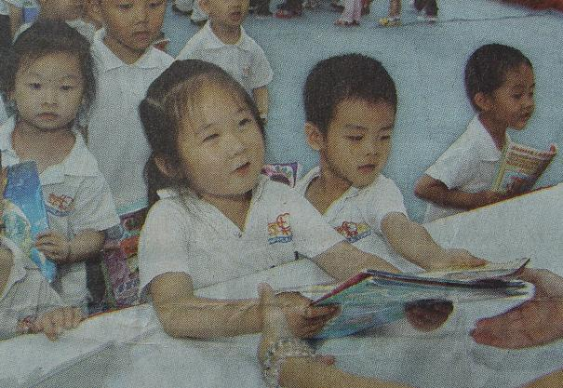
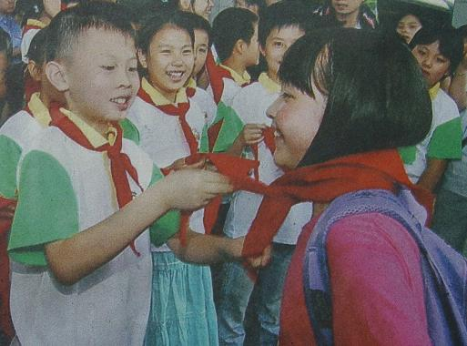
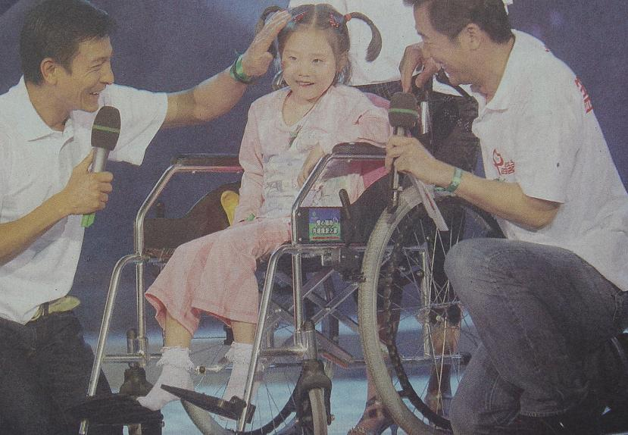

提示词：from disaster areas(灾区) unforgettable (难忘的)
A Special Children’s Day
Children’s Day is a great day for all the children and also for the children from disaster areas! __________________________________________________________________________________________________________________________________________________________________________________________________________________________________________________________________________________________________________________________________________________________________________________________________________________________________________________________________________________________
题目二：李小虎沉迷于电脑游戏中，影响了学习。作为他的好朋友，你打算怎么帮他呢？
请用下面所给的提示词写一篇短文。
提示词： give up concentrate on be (become)interested in
Li Xiaohu spent too much time playing computer games and fell behind others. ___________________________________________________________________________________________________________________________________________________________________________________________________________________________________________________________________________________________________________________________________________________________________________________________________________

湖北省咸宁市2008年初中毕业生学业考试
英语听力测试
同学们，请准备好！（音乐12秒）
准备好了吗？听力测试现在开始！

Ⅰ 听对话选图 听下面五则对话，根据对话内容，从每组A、B、C三个选项中，找出能回答所提问题的图片。（听完每则对话后，你都有10秒钟的时间作出选择和阅读下一小题。）每小题读两遍。
- W: Excuse me, but could you please not smoke in public places?
M: Sorry, madam. I can’t see the sign.

2. W: Father’s Day is coming soon, but what should I get for my father?
M: If I were you, I’d get tennis rackets. Your father likes sports, right?

3 M: I really want to be a basketball player. And you?
W: Oh, I’m going to be a policewoman when I grow up.

4. M: What a sunny day last Saturday!
W: Yes, and we all had a great time in the park!

5. M: I don’t like cats, they are lazy and they always sleep in the day.
W: But they are working while we are sleeping at night.

Ⅱ 对话理解 听下面三则对话，回答第6—15小题。从每小题A、B、C 三个选项中，找出相应问题的最佳答案。（听每则对话前，你有20秒钟的时间作出选择和阅读各个小题。）每则对话读两遍。

听第一则对话，回答第6—8 小题。

W: Good morning! Can I help you?
M: Yes, please. I want a T-shirt.
W: What size do you want?
M: Size M, please.
W: OK! What about this one?
M: Sorry! I don’t like black. Have you got any other colors?
W: Oh, yes. We’ve also got blue, brown and white ones.
M: Can I have a look at the brown ones?
W: Certainly.
M: How much is it?
W: $ 48.
M: OK, I’ll take it.

听第二则对话，回答第9—11 小题。

M: Hi, Kathy! What are your plans for the coming summer vacation?
W: I’ve no idea. Maybe I will spend it abroad.
M: Which country would you like to go to?
W: I’m not sure. I just want to relax because I feel very tired these days.
M: If I were you, I would go to Switzerland. It’s really a nice place.
W: I don’t think so.
M: What about Hawaii? There is lots of sunshine there all the year round.
W: Sounds interesting. Of course I could practice English as well. Thanks for your suggestion.
M: My pleasure.

听第三则对话，回答第12—15 小题。

W: Excuse me, could you tell me how far it is from our school to the zoo?
M: Sure. It’s only 15 minutes’ walk.
W: How can I get there? I’m new here, you know.
M: Well, walk along School Road to the traffic lights.
W: And then?
M: Then turn left and you’ll be on Green Street. There is a hotel on the corner and the zoo is right next to the hotel. You can’t miss it.
W: Thanks a lot for your help. By the way, could you tell me where I can get a cup of coffee?
M: Er… You can get it in the zoo.
W: Many thanks.
M: You’re welcome.

Ⅲ 短文理解 听下面一则短文，从每小题A、B、C 三个选项中，找出相应问题的最佳答案。（听短文前，你有30秒钟的时间阅读各小题。）短文读两遍。
Hello, boys and girls! Here is some information about our trip to the town of Chinese. We’ll go there by bus. It’s a long trip, over 4 hours. So we have to start early. The bus will wait for you at the school gate at 7:00 tomorrow morning. We’ll take some bread, water and apples for lunch with us and we will eat together in a park. After that we will walk around the old market. You will be able to buy all your presents there. We will meet at the place where our bus stops. If you are lost, please give me a call. My mobile phone number is 13726156656. Any questions? OK. See you tomorrow.

听力测试到此结束！

参考答案及评分说明

第一部分 听力测试 （共30分）
Ⅰ 听对话选图 每小题1分，共5分
1.B 2. A 3. C 4. A 5. B
Ⅱ 对话理解
6.B 7.A 8. C 9.B 10. C
11.A 12. B 13.C 14.B 15. A
Ⅲ 短文理解
16.C 17.B 18.C 19.A 20.A

第二部分 笔试 （90分）

Ⅳ 单项选择 （共15分，每小题1分）
21.C 22.A 23.D 24.D 25.C
26.C 27.A 28.C 29.C 30.A
31.D 32.A 33.B 34.B 35.B

Ⅴ 完形填空 （共15分，每小题1分）
36.B 37.A 38.B 39.D 40.D
41.B 42.A 43.A 44.C 45.D
46.D 47.C 48.D 49.A 50.B

Ⅵ 阅读理解 （每小题2分，共28分）
51.D 52.B 53.D 54.C 55.B
56.C 57.D 58.D 59.D 60.A
61. without , pay/money
62. excited enough
63. 一方有难，八方支援。
64. 只要语法正确，语句通顺，都可得满分。

Ⅶ 短文填空（注意共有12个空供你选做，每做对1个得1分，滿分10分！单词拼写或其它语法错误均不给分。）
65. makes 66. while 67. enjoying 68. most/many
69. still 70. nothing 71. water 72. died
73. careful 74. yourself 75. Swimming 76. remember

Ⅷ 补全对话 （每小题2分，共10分）
凡与本参考答案不同的，只要符合题意、句子连贯、语法正确，每个句子均可给满分；凡语句欠通顺或有语法错误的，可视错误程度，按0分、1分的档次给每个句子评分。
77.How do you like him/ What do you think of him
78. What does he look like / What is he like
79. Shall /May/ Can/ Could I meet/ know him
80. What’s the matter (with her)/ What’s wrong (with her) What’s her trouble
81. I’m sorry to hear that/ Sorry to hear that

Ⅸ 书面表达 （共12分）
本题要求两位教师单独评分，取平均分作为考生该题的得分。教师评卷时，应采用分项分档次的办法，先依据评分标准给出每项的档次分，然后相加。

附：评 分 项 目

评分项目 | 分值 | 档次 |  |  | 给分说明
评分项目 | 分值 | 好 | 中 | 差 | 给分说明
书写规范 | 2 | 2 | 1 | 0 | 标点及大小写错误0-1个属好，2-4个属中，5个以上属差。
短文长度 | 2 | 2 | 1 | 0 | 70-90个单词属好，30-69或90个以上属中，29个以下属差。
要点齐全 | 4 | 4 | 2 | 1 | 每个要点1分，允许合理想象。
句子通顺  语言准确 | 4 | 4 | 2 | 1 | 单词及语法错误0-1个属好，2-4个属中，5个以上属差。

One possible version(一)
Children’s Day is a great day for all the children and also for the children from disaster areas. They had an unforgettable Children’s Day this year! People all over the country are caring about them.
There were many special concerts held for them. In the concerts, they could sing with the famous singers like Liu Dehua. Some of them were invited to enjoy the day with other children from big cities. They sang, danced and played games together. Like the other children, they also got many beautiful gifts/ presents such as books, dolls, backpacks and so on.
I believe it was the happiest Children’s Day they had spent so far! How lucky they were!

One possible version(二)
Li Xiaohu spent too much time playing computer games and he fell behind others. As a good/close friend of his, I must do something to help him.
First, I must tell him that playing computer games too much is bad for his health, especially for his eyes. So he must give it up. I can play more sports with him after school. Maybe he will become more interested in sports than computer games.
And then I’ll ask him to concentrate more on his study. Of course, I will try my best to help him with all his subjects. I think I can do it in many fun ways and let him find much fun in studying.
At the same time, I’ll ask both his parents and our teachers to help him, too. If I try these, I’m sure he will make great progress soon.

声明：本资料由 考试吧（Exam8.com） 收集整理，转载请注明出自 http://www.exam8.com
服务：面向较高学历人群，提供计算机类，外语类，学历类，资格类，会计类，工程类，医学类等七大类考试的全套考试信息服务及考前培训.

