2007年北京市高级中等学校招生统一考试（大纲卷）
英语试卷

第I卷 （共78分）

第一部分 听力（24分）
一. 听简短叙述，选择正确答案。简短叙述朗读两遍。（共4分，每小题1分）
1. （ ）
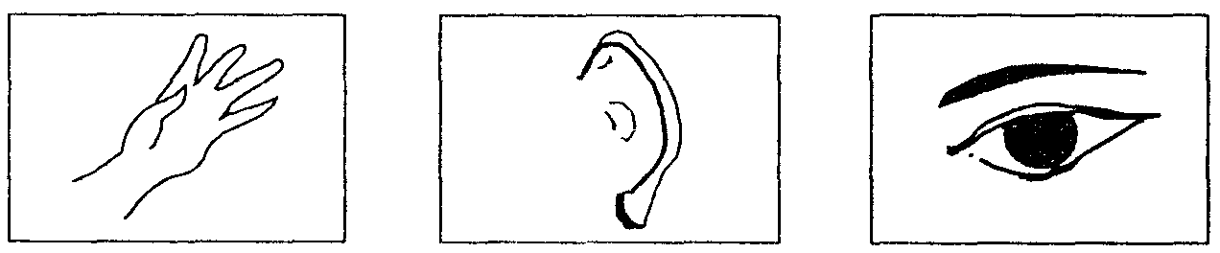
A B C

2. （ ）
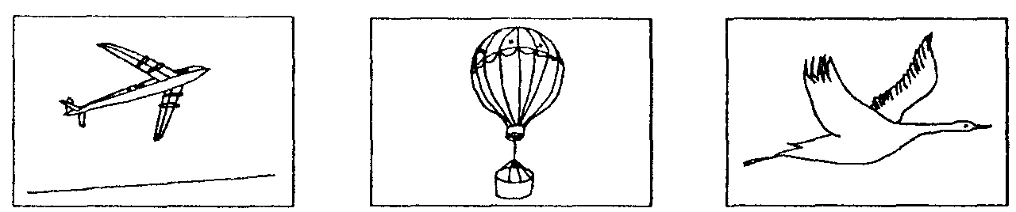
A B C
3. （ ）
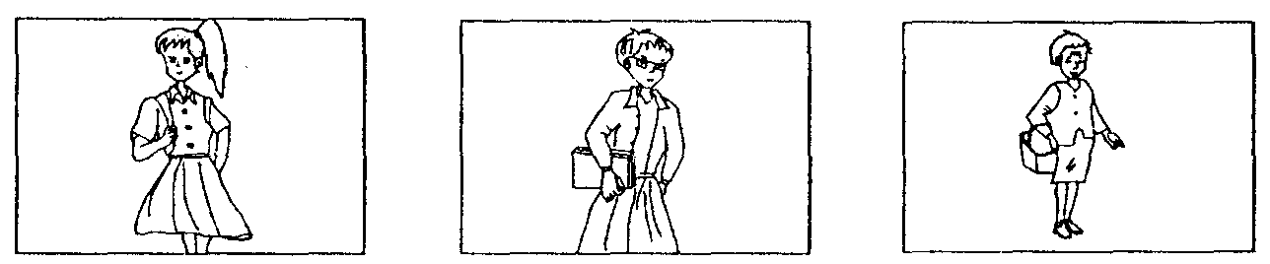
A B C
4. （ ）
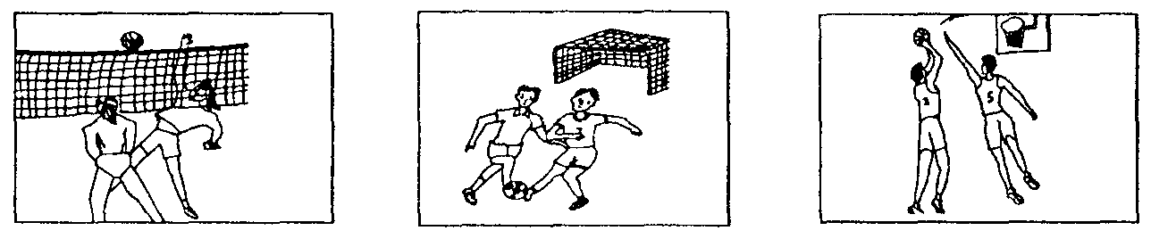
A B C

二. 听对话和对话后的问题，选择正确答案。对话和问题朗读两遍。（共6分，每小题1分）
5. A. By car. B. By bus. C. By bike.
6. A. To the bank. B. To the post office. C. To the cinema.
7. A. A pencil. B. A ruler. C. A pen.
8. A. Fine. B. Windy. C. Rainy.
9. A. At 9:00. B. At 9:15. C. At 9:30.
10. A. A farmer. B. A doctor. C. A teacher.

三. 听对话和短文，根据对话和短文的内容，选择正确答案。对话和短文朗读两遍。（共14分，每小题2分）
现在请听一段对话，完成第11、12小题。
11. How much is the jacket?
A. 24 dollars. B. 76 dollars. C. 100 dollars.
12. What color jacket did the man buy?
A. A blue jacket. B. A brown jacket. C. A black jacket.

现在请听一段短文，完成第13、14小题。
13. How many rooms have the people visited?
A. One. B. Two. C. Three.
14. What kind of book can be taken out of the library?
A. A dictionary. B. A novel. C. A magazine.

现在请听一段对话，完成15、16、17小题。
15. What are Jim Green and Helen Brown both good at?
A. Teaching children. B. Remembering things.
C. Meeting people.
16. Who mentioned a way to solve the weak-point problem?
A. Jim Green. B. Helen Brown. C. Ted King.
17. In which part didn’t Helen Brown make an expected reply?
A. Work experience. B. Strong points. C. Weak points.

第二部分 笔试（54分）
四. 语言知识运用（1）
（一）单项填空（共20分，每小题1分）
从下列各题所给的四个选项中选择可以填入空白处的最佳选项。
18. My parents gave __________ a nice toy dog for my birthday.
A. I B. me C. my D. mine
19. We traveled all night to London and got there __________ Sunday morning.
A. for B. on C. at D. to
20. —__________ did you have the party last night?
—In the park.
A. What B. Why C. When D. Where
21. __________ is watching TV. Let’s turn it off.
A. Somebody B. Anybody C. Nobody D. Everybody
22. I’d like to go shopping with you, __________ I’m too busy today.
A. but B. and C. so D. or
23. Welcome to our hotel. It’s __________ in the city.
A. good B. better C. best D. the best
24. The new term is coming. The students are busy __________ the classrooms.
A. clean B. cleans C. to clean D. cleaning
25. The children will climb the hill if it __________ tomorrow.
A. won’t rain B. didn’t rain C. doesn’t rain D. isn’t raining
26. —__________ you play golf?
—No. But I can play table tennis.
A. Can B. May C. Must D. Should
27. I had a bad cold. The doctor asked me __________ in bed.
A. staying B. to stay C. stayed D. stays
28. —Where’s your father, Mike?
—He __________ in the kitchen.
A. cooks B. cooked C. is cooking D. has cooked
29. Here’s my little cat. Please __________ it while I’m away.
A. look after B. look up C. look for D. look at
30. Mr. Smith __________ a talk on country music next Monday.
A. give B. gave C. has given D. will give
31. My brother hurt his __________ yesterday. He can’t walk now.
A. arm B. leg C. hand D. eye
32. It’s too cold here in winter. People have to wear __________ clothes.
A. warm B. new C. beautiful D. expensive
33. —Do you know __________ the MP3 player last week?
—Sorry, I have no idea.
A. how much did she pay for B. how much will she pay for
C. how much she paid for D. how much she will pay for
34. —Would you like to see the film with me?
—I’m sorry I __________it twice.
A. see B. will see C. have seen D. am seeing
35. Today Chinese __________ by more and more people around the world.
A. was spoken B. is spoken C. spoke D. speak
36. You look tired. You’d better __________ a good sleep.
A. have B. having C. had D. to have
37. —What good weather! Let’s go boating on the lake.
—__________.
A. That’s all right B. Thank you very much
C. It doesn’t matter D. That’s a good idea

（二）完形填空（共12分，每小题1分）
通读下面短文，掌握其大意，然后从短文后各题所给的四个选项中选择能填入相应空白处的最佳选项。
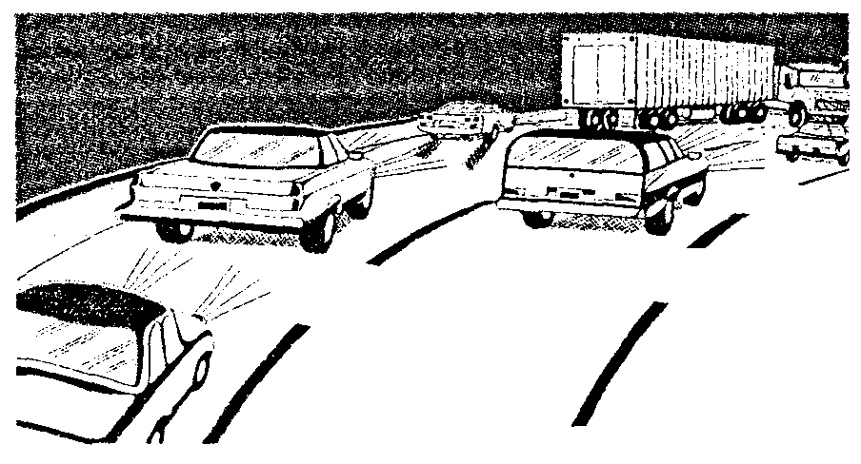
Jessie was driving home happily when a truck went past her car. The driver was moving much too fast. When Jessie neared her exit（出口）, she ___38___ something and stopped her car to the right of the highway（高速公路）. An accident had happened on the left side. The truck had ___39___ a car, but the driver was gone. Jessie thought that the people inside must be badly ___40___ and she should help them as much as she could.
Not thinking of the ___41___, Jessie hurried to the other side of the road, though few people dared（敢）cross such a busy road. Looking into the car, she saw five people —two women and three children. Jessie was ___42___ to see all of them moving.
Jessie pulled one of the car doors. It wouldn’t open. She went to the next door. ___43___, she couldn’t move it. She almost thought that all was ___44___ before she got one of the doors to open a little. “Please get the children out,” one of the women called. Jessie ___45___ a little boy from the car and moved him to a ___46___ place. Then she went to bring the other children to safety.
After the last child was out of the car, Jessie thought of the box in ___47___ car. She had something in it that could help get that door open. So she got the box quickly. As Jessie was ___48___ on the door, the driver said, “Not many people would do what you’re doing.” “Your just take it easy, and I’ll have you ___49___ soon,” said Jessie. She was as good as her word. As soon as she helped the women out of the car, it caught fire.
38. A. did B. saw C. made D. forgot
39. A. hit B. met C. passed D. followed
40. A. beaten B. treated C. needed D. hurt
41. A. matter B. trouble C. danger D. accident
42. A. proud B. happy C. nervous D. worried
43. A. Again B. Clearly C. Perhaps D. Exactly
44. A. expected B. missed C. lost D. found
45. A. picked B. dropped C. collected D. pulled
46. A. quiet B. cool C. safe D. clean
47. A. their B. her C. another D. this
48. A. working B. turning C. knocking D. setting
49. A. back B. past C. over D. out

五. 阅读理解（共22分，每小题2分）
阅读下面A、B、C三篇短文。根据短文内容从每题所给的四个选项中选择最佳选项。
（A）
TV Programs

50. What kind of program is 24 HOURS?
A. Talk show. B. Film. C. Game show. D. Cooking.
51. What’s on Channel 19 at 6:30?
A. CHINESE COOK B. SPORTS WORLD
C. MEND IT YOURSELF D. MONEY TALK
52. Who does Ken Cleveland interview?
A. A student. B. A cook. C. A rich singer. D. A tennis player.

（B）
A bully is a person who enjoys hurting other people. A bully can hurt people with words or by hitting them. 85% of children in the UK have been bullied（欺侮）at least once.
How can I tell if a person is a bully?
He or she will…
·try to find your weak point—perhaps you are shy, nervous or easily made worried.
·make fun of（取笑）you in front of your friends.
·borrow money then won’t pay you back.
What can I do if a bully bothers （骚扰）me?
·Tell the bully to leave you alone.
·Do not be afraid to ask other people for help, even though the bully tells you not to.
·Do not feel ashamed（羞愧）because you have been bullied. You have done nothing wrong! The bully should feel ashamed.
·Do not believe the bad things a bully says about you.
What should I do if I see a bully bothering someone?
·Help people who are being bullied, even though you don’t know them.
·Be a friend to people who are bullied.
·Tell a teacher if you see bullying.
·Tell bullies to stop. Sometimes bullies are afraid, too.
Why do some people become bullies?
Some bullies…
·have never learnt to think about other people’s feelings.
·don’t like themselves, so they are sad. They think they will be happy if they make another person sad.
·have been bullied themselves by other bullies.
Can bullies change?
Yes! Bullies can change when they learn to think about other people’s feelings.
Sometimes bullies must be punished（惩罚）before they understand. Sometimes, bullies just need friends.

53. A bully often _________.
A. makes people think about themselves
B. borrows money but doesn’t return
C. helps people when they are in trouble
D. thinks about other people’s feelings
54. If you see a bully bothering your friends, you should _________.
A. leave them alone
B. help them stop the bully
C. make them ashamed
D. tell them they are wrong
55. Which of the following is true?
A. Bullies say bad words to people.
B. Bullies like themselves very much.
C. Bullies make people around them happy.
D. Bullies must always be punished.
56. What would be the best title for the passage?
A. Bullies Can Change
B. World Without Bullying
C. Bullying Is Everywhere
D. Bullying Around Us

（C）
Matt Mason has seen the future—and it’s fun. Mason likes thinking about how machines can make our lives easier by doing the work we hate, such as cleaning. He shows a hard floor cleaning system（系统）that’s built into the wall: it will blow dirt to a part of the room where it will be collected by a vacuum（吸尘器）. Then the system will drop some cleaner on the floor and an arm will mop（用拖把擦）it up. “This may trouble you,” says Kara, an expert in Mason’s company. “But you can program it to come on at 3 a. m., and it will just wet-mop the floor for you.”
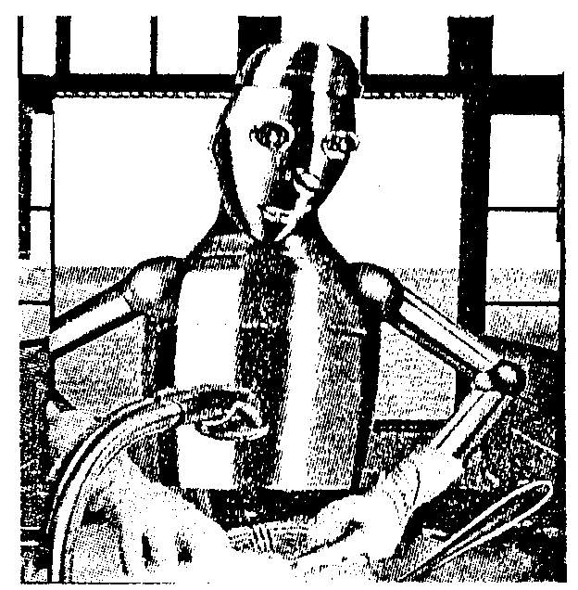
When it comes to the kitchen, Bruce Beihoff, another expert at Whirlpool, is sure that in a few years, robots will be doing most of the boring work, freeing us to relax. “More than just fun, future kitchens will be environmentally friendly,” he says. “A new system will be built in the house which can recycle energy（能量）lost from your kitchen to make the whole home warm.”
“The fridge will be the center of the home,” says Daniel Lee, a market expert. The fridge will have a touch screen （触摸屏幕）where you can watch TV, surf the Internet, check your e-mail, keep a shopping list and order vegetables. “Your fridge is the first place you go in the morning and the last place at night,” says Lee.
Ever wonder why a 1.9-meter man and a 1.6-meter woman have to cook meals on counters（工作台）of the same height. “The height was decided over 50 years ago, according to the height of ordinary women,” says Jane Langmuir, an expert of cooking machines. “But times have changed. We have made a new counter where you press a button and it moves to whatever height you want.” At the same time, Ted Selker at MIT’s Counter lab has made the Dishmaker which lets you make dishes and bowls out of plastics at home. After each meal, the dishes are changed straight back into plastics.

57. How many inventions are mentioned in the passage?
A. Three. B. Four. C. Five. D. Six.
58. In future, if you want to clean your house, you will _________.
A. have a recycling system built in the wall
B. get up early to start your cleaning system
C. use your fridge to give orders to a cleaner
D. leave the work to a kind of cleaning machine
59. What is future kitchen work like?
A. Terrific and relaxing. B. Easy and interesting.
C. Enjoyable and exciting. D. Funny and amazing.
60. From the passage, we know _________.
A. people will have more and more time enjoying themselves
B. future kitchens can provide all the energy for our life every day
C. the fridge can be found in the center of a future house
D. people must be expert at computers to use these inventions

第II卷 （共42分）

一. 语言知识运用（2）（共10分，每小题2分）
根据中文意思完成句子。
1. 六点钟了，该吃晚饭了。
It’s six o’clock. __________________ supper.
2. 博物馆很近，为什么不走着去呢？
The museum is quite near. __________________ on foot?
3. 我的电脑坏了，你能帮我修一下吗？
____________________________________ my computer. Could you help me mend it?
4. 很抱歉让你久等了。
I’m sorry ___________________________ for a long time.
5. 他过去玩电脑游戏的时间太多，结果对学习不感兴趣了。
_________________________________________ he was not interested in his lessons.

二. 口语交际（共10分，每小题2分）
根据上下文的意思补全对话。在横线上写出所缺少的内容。
Susan: Hello, _________6________ Kate?
Mike: Sorry, she isn’t in right now. Is that Susan speaking?
Susan: yes. Who’s that?
Mike: This is Mike ________________________?
7
Susan: Fine, thanks. Can I leave a message?
Mike: Of course. __________________, please. I’ll go and get a pen.
8
(Soon Mike returns.)
Mike: OK, please.
Susan: I’d like to ask her if she will go to the English Festival next week.
Will you please tell her to call me back when she returns?
Mike: No problem. ____________________________________?
9
Susan: It’s 78340631.
Mike: OK, bye-bye.
Susan: Thanks. ___________________________.
10

三. 阅读与表达（共10分，每小题2分）
阅读短文，根据其内容回答问题。
Americans love sports—they love to play them, to watch them on television, and to talk about them. But this hobby sometimes has serious results—at least to the players. For example, when people play tennis, sometimes they hurt their elbow（肘部）and in this way they develop “tennis elbow”. Also it is easy to hurt a knee in a football game. These injuries（损伤）happen while the player is having fun, but they still hurt.
A few months ago, Kathleen Simmons, who loves playing volleyball, hurt her knee in a volleyball game. Her doctor told her that she needed a very difficult operation（手术）or she might not be able to play again. She felt very sad and didn’t know what to do.
Then Simmons learned about “video operation”. With the help of this new science in medicine, doctors can now repair many injuries and get people back on the playing field and back to their jobs much faster. Simmons found a hospital that was using this new science and went to see the doctor there. The doctors told her the operation could help.
For this operation, her doctor didn’t have to open her knee. Instead he put a very small camera lens（镜头）inside her knee. The lens sent back pictures, which appeared on a television screen. As he worked, he could see the inside of her knee on the TV. With the help of the large pictures on the screen, the doctor knew exactly what to do when he was making the repairs.
Simmons started walking five days after her operation. “My knee hurt a lot the first few days,” she said. “But I felt better very quickly.” Now, six months after her operation, Simmons can do everything she did before her injury. “It feels like a new knee,” she said. “I can even play volleyball again.”
11. Do Americans love sports?
_____________________________________________
12. What sport is Simmons interested in?
_____________________________________________
13. What did the doctor put inside Simmons’ knee?
_____________________________________________
14. What problem may people have when they play sports?
_____________________________________________
15. What’s the advantage（优点）of the new science?
_____________________________________________

四. 写作
（一）单句表达（共4分，每小题1分）
根据中文意思和英文提示词语，写出四句语法正确、意思连贯的话。
彼得是一个美国男孩，他喜欢旅游。他经常做些什么？2008年他将要做什么？
16. Peter, be, an American boy
______________________________________________________
17. he, like, travelling
______________________________________________________
18. he, often, go to different countries
______________________________________________________
19. he, will come to Beijing, to watch, the Olympic Games, 2008
______________________________________________________

（二）文段表达（8分）
根据中文提示和英文书信内容，写一封意思连贯、符合逻辑、不少于50词的回信。（信的开头和结尾已给出，其字数不计入所完成的回信内）
20. 假如你叫李玲，是英国中学生露茜的笔友，你收到了她的电子邮件。请根据她来信的内容写一封回信。针对她的困惑，谈谈你的看法，同时提出一些建议，告诉她应该做什么，不应该做什么。
Dear Li Ling,
These days Tom Cruise, the film star, always comes into my mind. I think of him night and day. I just sit in my room and watch videos of his films again and again. I’ve written hundreds of letters to him and sent e-mails to his fan club, but all I get back are only photos with his names on them. I dream that some day I’ll meet him and that he’ll feel the same way about me. I don’t want to learn my lessons any more, and I’ll have final exams next month.
I’m thinking of running away to Hollywood（好莱坞）to meet him. Can you help me with the problem?
Yours,
Lucy
Hi Lucy,
Nice to hear from you. __________________________________________
_____________________________________________________________________________
_____________________________________________________________________________
Yours,
Li Ling
2007年北京市高级中等学校招生统一考试（大纲卷）
英语试卷

参考答案

第I卷
1. C 2. A 3. B 4. C 5. C
6. A 7. A 8. A 9. C 10. B
11. B 12. A 13. C 14. B 15. C
16. B 17. A 18. B 19. B 20. D
21. C 22. A 23. D 24. D 25. C
26. A 27. B 28. C 29. A 30. D
31. B 32. A 33. C 34. C 35. B
36. A 37. D 38. B 39. A 40. D
41. C 42. B 43. A 44. C 45. D
46. C 47. B 48. A 49. D 50. A
51. D 52. C 53. B 54. B 55. A
56. D 57. C 58. D 59. B 60. A

第II卷
一. 语言知识运用（2）
1. It’s time for/ to have
2. Why not go (there)
3. There is something wrong with
4. to keep you waiting
5. He spent so much time（in）playing computer games that

二. 口语交际
6. may I speak to
7. How are you
8. Hold on
9. What’s your telephone number
10. Bye/See you

三. 阅读与表达
11. Yes. /Yes, they do.
12. Volleyball.
13. A camera lens.
14. They may get hurt.
15. Doctors can do operations more easily and patients can get well more quickly.

四. 写作
（一）单句表达
16. Peter is an American boy.
17. He likes travelling.
18.He often goes to different countries.
19. He will come to Beijing to watch the Olympic Games in 2008.

（二）文段表达
20. One possible version:
Hi Lucy,
Nice to hear from you. Everyone has his favorite stars and there’s nothing wrong with that. I understand you. But I don’t think what you do is right since you are a student. You’d better read more interesting books and have more sports in your free time. Stop writing to him and watching his films. You may also tell your problem to your parents and teachers. I’m sure they’ll help you. Running away to Hollywood is a wrong idea. Work hard on your lessons and get ready for the exams. Your future is in your hands.
Yours,
Li Ling

［听力测试录音稿］
一. 听简短叙述，选择正确答案。
1. It’s a part of our body. Each person has got two of them. They are in our faces. People see the world with them.
2. It can take hundreds of passengers and travel very fast in the air. Before it flies, it has to run a long way on the ground.
3. This is a really pretty girl. She has very short hair and wears a pair of glasses. She’s holding some books in her hand.
4. On the playground, two teams are having a match. One player has got the ball, and he’s trying to throw it into the basket.

二. 听对话和对话后的问题，选择正确答案。
5. Girl: Do you usually go to school by bus?
Boy: No, I don’t. I go to school by bike.
Question: How does the boy usually go to school?
6. Man: Excuse me, where’s the nearest bank, please?
Woman: Go along this street, and turn left. You’ll see the bank next to the post office.
Man: Thank you.
Question: Where’s the man going?
7. Girl: Excuse me, may I use your pen, Bob?
Boy: Sorry, I only have a pencil.
Question: What does Bob have?
8. Man: What’s the weather like today?
Woman: It’s fine. But the TV says it’s going to be windy and rainy tomorrow.
Question: What’s the weather like today?
9. Woman: What time is it now?
Man: It’s nine fifteen. And when will the meeting begin?
Woman: At nine thirty.
Question: When will the meeting begin?
10. Man: What’s your trouble, madam?
Woman: I have a headache and feel terrible.
Man: Open your mouth and say “Ah…”.
Woman: Ah….
Question: What does the man do?

三. 听对话和短文，根据对话和短文内容，选择正确答案。
现在请听一段对话，完成第11、12小题。
Shop assistant: Can I help you, sir?
Man: Yes, I’m looking for a jacket.
Shop assistant: What’s your size, please?
Man: Size L.
Shop assistant: What color do you prefer?
Man: I like brown.
Shop assistant: Mm, I’m sorry we haven’t got any brown jackets in that size. How about a blue one or a black one?
Man: May I try on a blue one?
Shop assistant: Of course.
Man: Oh, it looks nice on me. I’ll take it. How much is it?
Shop assistant: 76 dollars.
Man: OK. Here’s one hundred.
Shop assistant: Thank you. Your change, please

现在请听一段短文，完成第13、14小题。
I’m Bill Smith. I work in this university library, and today I’d like to tell you something about our library and show you how to use it. In the first room on our visit, you can find all kinds of dictionaries, guides and even telephone books. You may use these books only in this room itself. OK, let’s go to the next room. It’s a reading room. Different kinds of newspapers and magazines are kept here. You can always get them by yourselves. But they mustn’t be taken out of this room. Now, we are in the third room. In this room you can borrow novels, storybooks and science books. All the library’s books are listed here by title, by writer and by topic. When you are looking for a book, you must write the book’s call number, title and writer on these pieces of paper and give them to the person who works here together with your library card. You must return the book in two weeks. OK, that’s all. If you have any further questions about using the library, I’d be glad to help you. Thank you.

现在请听一段对话，完成第15、16、17小题。
Interviewer: Good morning. I’m Ted King. I know both of you are interested in the job. I’d like you to talk about yourselves. First please tell me something about your work experience.
Woman: My name’s Helen Brown. I’m married and I have 2 children and we just moved to town because the schools here are good. I hope my children will get a better education than I got. Our schools were terrible. The classes were huge and we never did anything interesting.
Man: My name’s Jim Green. I’m a part-time student at Boxfield Community College, but I have also worked at a number of different part-time jobs since I moved here. My most interesting job so far was at the college library where I helped to mend computers.
Interviewer: You know, everybody has strong points and weak points. Would you please talk about your strong points?
Woman: I’d say my strong point is that I’m good at getting to know people. Many people don’t like meeting new people but I love it. I seem to be able to make people feel comfortable right away. Maybe it’s because I really enjoy listening to them.
Man: Well, I think I make friends very easily. When I meet someone, I remember him and try to see him again later. At my last birthday party there were more than 50 friends in my house.
Interviewer: Now please tell me your weak points and what you do about them.
Woman: I enjoy talking to people and I know that in the past I have spent too much time on the telephone. Now I watch the clock while I’m making phone calls and I’ve cut my telephone time in half.
Man: I also have trouble getting off the telephone. I just enjoy talking with my friends, but it takes me a lot of time. Some days I spend hours on the phone.

2007年北京市高级中等学校招生统一考试（大纲卷）
英语试卷

参考答案

第I卷
1. C 2. A 3. B 4. C 5. C
6. A 7. A 8. A 9. C 10. B
11. B 12. A 13. C 14. B 15. C
16. B 17. A 18. B 19. B 20. D
21. C 22. A 23. D 24. D 25. C
26. A 27. B 28. C 29. A 30. D
31. B 32. A 33. C 34. C 35. B
36. A 37. D 38. B 39. A 40. D
41. C 42. B 43. A 44. C 45. D
46. C 47. B 48. A 49. D 50. A
51. D 52. C 53. B 54. B 55. A
56. D 57. C 58. D 59. B 60. A

第II卷
一. 语言知识运用（2）
1. It’s time for/ to have
2. Why not go (there)
3. There is something wrong with
4. to keep you waiting
5. He spent so much time（in）playing computer games that

二. 口语交际
6. may I speak to
7. How are you
8. Hold on
9. What’s your telephone number
10. Bye/See you

三. 阅读与表达
11. Yes. /Yes, they do.
12. Volleyball.
13. A camera lens.
14. They may get hurt.
15. Doctors can do operations more easily and patients can get well more quickly.

四. 写作
（一）单句表达
16. Peter is an American boy.
17. He likes travelling.
18.He often goes to different countries.
19. He will come to Beijing to watch the Olympic Games in 2008.

（二）文段表达
20. One possible version:
Hi Lucy,
Nice to hear from you. Everyone has his favorite stars and there’s nothing wrong with that. I understand you. But I don’t think what you do is right since you are a student. You’d better read more interesting books and have more sports in your free time. Stop writing to him and watching his films. You may also tell your problem to your parents and teachers. I’m sure they’ll help you. Running away to Hollywood is a wrong idea. Work hard on your lessons and get ready for the exams. Your future is in your hands.
Yours,
Li Ling

［听力测试录音稿］
一. 听简短叙述，选择正确答案。
1. It’s a part of our body. Each person has got two of them. They are in our faces. People see the world with them.
2. It can take hundreds of passengers and travel very fast in the air. Before it flies, it has to run a long way on the ground.
3. This is a really pretty girl. She has very short hair and wears a pair of glasses. She’s holding some books in her hand.
4. On the playground, two teams are having a match. One player has got the ball, and he’s trying to throw it into the basket.

二. 听对话和对话后的问题，选择正确答案。
5. Girl: Do you usually go to school by bus?
Boy: No, I don’t. I go to school by bike.
Question: How does the boy usually go to school?
6. Man: Excuse me, where’s the nearest bank, please?
Woman: Go along this street, and turn left. You’ll see the bank next to the post office.
Man: Thank you.
Question: Where’s the man going?
7. Girl: Excuse me, may I use your pen, Bob?
Boy: Sorry, I only have a pencil.
Question: What does Bob have?
8. Man: What’s the weather like today?
Woman: It’s fine. But the TV says it’s going to be windy and rainy tomorrow.
Question: What’s the weather like today?
9. Woman: What time is it now?
Man: It’s nine fifteen. And when will the meeting begin?
Woman: At nine thirty.
Question: When will the meeting begin?
10. Man: What’s your trouble, madam?
Woman: I have a headache and feel terrible.
Man: Open your mouth and say “Ah…”.
Woman: Ah….
Question: What does the man do?

三. 听对话和短文，根据对话和短文内容，选择正确答案。
现在请听一段对话，完成第11、12小题。
Shop assistant: Can I help you, sir?
Man: Yes, I’m looking for a jacket.
Shop assistant: What’s your size, please?
Man: Size L.
Shop assistant: What color do you prefer?
Man: I like brown.
Shop assistant: Mm, I’m sorry we haven’t got any brown jackets in that size. How about a blue one or a black one?
Man: May I try on a blue one?
Shop assistant: Of course.
Man: Oh, it looks nice on me. I’ll take it. How much is it?
Shop assistant: 76 dollars.
Man: OK. Here’s one hundred.
Shop assistant: Thank you. Your change, please
现在请听一段短文，完成第13、14小题。
I’m Bill Smith. I work in this university library, and today I’d like to tell you something about our library and show you how to use it. In the first room on our visit, you can find all kinds of dictionaries, guides and even telephone books. You may use these books only in this room itself. OK, let’s go to the next room. It’s a reading room. Different kinds of newspapers and magazines are kept here. You can always get them by yourselves. But they mustn’t be taken out of this room. Now, we are in the third room. In this room you can borrow novels, storybooks and science books. All the library’s books are listed here by title, by writer and by topic. When you are looking for a book, you must write the book’s call number, title and writer on these pieces of paper and give them to the person who works here together with your library card. You must return the book in two weeks. OK, that’s all. If you have any further questions about using the library, I’d be glad to help you. Thank you.
现在请听一段对话，完成第15、16、17小题。
Interviewer: Good morning. I’m Ted King. I know both of you are interested in the job. I’d like you to talk about yourselves. First please tell me something about your work experience.
Woman: My name’s Helen Brown. I’m married and I have 2 children and we just moved to town because the schools here are good. I hope my children will get a better education than I got. Our schools were terrible. The classes were huge and we never did anything interesting.
Man: My name’s Jim Green. I’m a part-time student at Boxfield Community College, but I have also worked at a number of different part-time jobs since I moved here. My most interesting job so far was at the college library where I helped to mend computers.
Interviewer: You know, everybody has strong points and weak points. Would you please talk about your strong points?
Woman: I’d say my strong point is that I’m good at getting to know people. Many people don’t like meeting new people but I love it. I seem to be able to make people feel comfortable right away. Maybe it’s because I really enjoy listening to them.
Man: Well, I think I make friends very easily. When I meet someone, I remember him and try to see him again later. At my last birthday party there were more than 50 friends in my house.
Interviewer: Now please tell me your weak points and what you do about them.
Woman: I enjoy talking to people and I know that in the past I have spent too much time on the telephone. Now I watch the clock while I’m making phone calls and I’ve cut my telephone time in half.
Man: I also have trouble getting off the telephone. I just enjoy talking with my friends, but it takes me a lot of time. Some days I spend hours on the phone.
声明：本资料由 考试吧（Exam8.com） 收集整理，转载请注明出自 http://www.exam8.com
服务：面向较高学历人群，提供计算机类，外语类，学历类，资格类，会计类，工程类，医学类等七大类考试的全套考试信息服务及考前培训.

